Preventing Extremism
and
Radicalisation Policy 2026
Policy Review

The policy was last reviewed and agreed by the Governing Body on ……………….……..………………………….
It is due for review on …………………………………..………………

Head Teacher Signature ………………………………………..……. Date ……………………

Chair of Governors Signature …………………………..….………………. Date ….…………………


Introduction

Since 2010, when the Government published the Prevent Strategy, there has been an awareness of the specific need to safeguard children, young people and families from violent extremism. There have been several occasions both locally and nationally in which extremist groups have attempted to radicalise vulnerable children and young people to hold extreme views including views justifying political, religious, sexist or racist violence, or to steer them into a rigid and narrow ideology that is intolerant of diversity and leaves them vulnerable to future radicalisation.
The aim of Prevent is to stop people from becoming terrorists or supporting terrorism. The objectives of Prevent are to:
- tackle the ideological causes of terrorism
- intervene early to support people susceptible to radicalisation
- enable people who have already engaged in terrorism to disengage and rehabilitate

Palfrey Junior School values freedom of speech and the expression of beliefs / ideology as fundamental rights underpinning our society’s values. Both students and teachers have the right to speak freely and voice their opinions. However, freedom comes with responsibility and free speech that is designed to manipulate the vulnerable or that leads to violence and harm of others goes against the moral principles in which freedom of speech is valued. Free speech is not an unqualified privilege; it is subject to laws and policies governing equality, human rights, community safety and community cohesion.

Palfrey Junior School is committed to providing a secure environment for pupils, where children and young people feel safe and are kept safe. All adults at the school recognise that safeguarding is everyone’s responsibility irrespective of the role they undertake or whether their role has direct contact or responsibility for children or not.

This Preventing Extremism and Radicalisation Policy is one element within our overall school arrangements to safeguard and promote the welfare of all children in line with our statutory duties set out at S157/S175 of the Education Act 2002.

Our school’s Preventing Extremism and Radicalisation Policy also draws upon the guidance produced by the Walsall Local Safeguarding Partnership ; DfE Guidance “Keeping Children Safe in Education, 2025”, HM government document “Prevent strategy: A guide for local partners in England” and the “Counter Terrorism and Security Act 2015” and the most up-to-date guidance “Prevent duty guidance: Guidance for specified authorities in England and Wales 2023”. This is statutory guidance for England and Wales, issued on 7 September 2023 under Section 29 of the Counter-Terrorism and Security Act 2015. Subject to Parliamentary approval, it comes into force on 31 December 2023.
The Counter-Terrorism and Security Act 2015 contains a duty on specified authorities, which includes all schools including academies, free schools, maintained schools and studio schools to have due regard to the need to prevent people from being drawn into terrorism. The new legislation will be measured through various inspection frameworks, with schools and Children Services measured through OFSTED. The government will be producing guidance to help schools deliver the required standards (issued under section 29 of the Act).
Niall Markham is the Prevent Coordinator for Walsall & Contact details naill.markham@walsall.gov.uk 01922 654499 or 07766 160646

The Department for Education has set up a helpline for teachers who have questions and/or concerns about extremism. Helpline 0207 340 7264 or email: counter.extremism@education.gsi.gov.uk

School Ethos and Practice
When operating this Policy, the school uses the following accepted Governmental definition of extremism which is:

‘Vocal or active opposition to fundamental British values, including democracy, the rule of law, individual liberty and mutual respect and tolerance of different faiths and beliefs; and/or calls for the death of members of our armed forces, whether in this country or overseas’.

There is no place for extremist views of any kind in our school, whether from internal sources (pupils, staff or governors) or external sources (school community, external agencies or individuals). Our pupils see our school as a safe place where they can explore controversial issues safely and where our teachers encourage and facilitate this – we have a duty to ensure this happens.

As a school we recognise that extremism and exposure to extremist materials and influences can lead to poor outcomes for children and so should be addressed as a safeguarding concern as set out in this Policy. We also recognise that if we fail to challenge extremist views we are failing to protect our pupils.

Extremists of all persuasions aim to develop destructive relationships between different communities by promoting division, fear and mistrust of others based on ignorance or prejudice and thereby limiting the life chances of young people. Education is a powerful weapon against this; equipping young people with the knowledge, skills and critical thinking, to challenge and debate in an informed way.

Therefore, the school will provide a broad and balanced curriculum, delivered by skilled professionals, so that our pupils are enriched, understand and become tolerant of difference and diversity and also to ensure that they thrive, feel valued and not marginalized.

Please see notes on associated terminology on appendix 1

The Counter Terrorism and Security Act July 2015
The Counter Terrorism and Security Act 2015 was published on 26th November 2014 (updated February 2015). Section 26 of the Act places a duty on schools in England (and Wales) to prevent people being drawn into terrorism. This duty applies to all schools, whether publicly-funded or independent, and organisations covered by the Early Years Foundation Stage framework. The duty also applies to children’s homes.

Schools leaders (including governors) must:
- establish or use existing mechanisms for understanding the risk of extremism
- ensure staff understand the risk and build capabilities to deal with it
- communicate and promote the importance of the duty
- ensure staff implement the duty effectively

Other duties on schools include:
- Effective partnership working with other local agencies, e.g. Local Safeguarding Partnerships, police, health, etc.
- information sharing
- maintaining appropriate records
- assessing local risk of extremism (including Far Right extremism)
- demonstrating they are protecting children
- developing clear protocols for visiting speakers
- safeguarding policies that take account of Local Safeguarding Partnership policies and procedures
- training staff to give them knowledge and confidence
- ensuring there is robust ICT protocols that filter out extremist materials
- school buildings must not be used to give a platform to extremists

Ofsted are responsible for monitoring how well schools are implementing this duty.

Recognising the indicators of vulnerability to radicalisation

There is no such thing as a “typical extremist”: those who become involved in extremist actions come from a range of backgrounds and experiences, and most individuals, even those who hold radical views, do not become involved in violent extremist activity.

Pupils may become susceptible to radicalisation through a range of social, personal and environmental factors - it is known that violent extremists exploit vulnerabilities in individuals to drive a wedge between them and their families and communities. It is vital that school staff are able to recognise those vulnerabilities.

Indicators of vulnerability include:

- Identity Crisis – the student / pupil is distanced from their cultural / religious heritage and experiences discomfort about their place in society;
- Personal Crisis – the student / pupil may be experiencing family tensions; a sense of isolation; and low self-esteem; they may have dissociated from their existing friendship group and become involved with a new and different group of friends; they may be searching for answers to questions about identity, faith and belonging;
Personal Circumstances – migration; local community tensions; and events affecting the student / pupil’s country or region of origin may contribute to a sense of grievance that is triggered by personal experience of racism or discrimination or aspects of Government policy;
- Unmet Aspirations – the student / pupil may have perceptions of injustice; a feeling of failure; rejection of civic life;
- Experiences of Criminality – which may include involvement with criminal groups, imprisonment, and poor resettlement /reintegration;
- Special Educational Need – students / pupils may experience difficulties with social interaction, empathy with others, understanding the consequences of their actions and awareness of the motivations of others.

More critical risk factors could include:
- Being in contact with extremist recruiters;
- Accessing violent extremist websites, especially those with a social networking element;
- Possessing or accessing violent extremist literature;
- Using extremist narratives and a global ideology to explain personal disadvantage;
- Justifying the use of violence to solve societal issues;
- Joining or seeking to join extremist organisations; and
- Significant changes to appearance and / or behaviour;
- Experiencing a high level of social isolation resulting in issues of identity crisis and/or personal crisis.

Any prejudice, discrimination or extremist views, including derogatory language, displayed by pupils or staff will always be challenged and where appropriate dealt with in line with our Behaviour Policy for pupils and the Code of Conduct/Staff Behaviour policy for staff.

We will ensure that all of our staff are equipped to recognise extremism and are skilled and confident enough to challenge it. All staff will receive WRAP training every two years (Workshop to Raise Awareness of Prevent) and radicalisation and extremism will be an integral part of annual staff safeguarding training. WRAP Training completed 2nd September 2024
Our school is required to identify a Prevent Single Point of Contact (SPOC) who alongside the designated PREVENT lead will be the lead within the organisation for safeguarding in relation to protecting individuals from radicalisation and involvement in terrorism.
The Single Point of Contact (SPOC) for Palfrey Juniors is Hayley Thomson and PREVENT Leads are Emily Kinsey & Cheryl Collis (Head Teachers )as part of their DSL roles.

When any member of staff has concerns that a pupil may be at risk of radicalisation or involvement in terrorism, they should speak with the SPOC or head/principal. We will help support pupils who may be vulnerable to such influences as part of our wider safeguarding responsibilities and where we believe a pupil is being directly affected by extremist materials or influences we will ensure that that pupil is offered assistance. Additionally, in such instances our school will seek external support from the Local Authority and/or local partnership structures working to prevent extremism.

Any concerns to be reported to MASH 0300 555 2866. Advice and guidance can be sought from MASH or Niall Markham naill.markham@walsall.gov.uk 01922 654499 or 07766 160646

Our school will closely follow the locally agreed procedure as set out by the Local Safeguarding Partnership for safeguarding individuals vulnerable to extremism and radicalisation. www.wlscb.org.uk

Teaching Approaches
We will all strive to eradicate the myths and assumptions that can lead to some young people becoming alienated and disempowered, especially where the narrow approaches children may experience elsewhere may make it harder for them to challenge or question these radical influences. In our school this will be achieved by good teaching, primarily via Citizenship and PSHE sessions; but also by adopting the methods outlined in the Government’s guidance ‘Teaching approaches that help build resilience to extremism among young people’ DfE 2011. These approaches include setting targets for young people to build a sense of ownership; creating a safe space for dialogue between staff and pupils; building resilience in pupils; improving pupil skills for collaborative work; improving pupils’ ability to interact with each other and a peer mentoring scheme. Weekly PHSE SCARF lessons reinforce and teach safety, caring for others, achievements and self-esteem, resilience, friendships and positive relationships.

Through weekly Votes for schools, children are given the opportunity to share their views and opinions on a range of current affair topics. We will ensure that all of our teaching approaches help our pupils build resilience to extremism and give pupils a positive sense of identity through the development of critical thinking skills. The school will promote the values of democracy, the rule of law, individual liberty, mutual respect and tolerance for those with different faiths and beliefs. We will teach and encourage pupils to respect one another and to respect and tolerate difference, especially those of a different faith or no faith. It is indeed our most fundamental responsibility to keep our pupils safe and prepare them for life in modern multi-cultural Britain and globally.

We will also work with local partners, PREVENT officer, Street Teams, NSPCC local PSCO & Police, families and communities in our efforts to challenge extremist views and to assist in the broadening of our pupils’ experiences and horizons.

Use of External Agencies and Speakers
The school encourages the use of external agencies or speakers to enrich the experiences of our pupils; however, we will positively vet those external agencies, individuals or speakers who we engage to provide such learning opportunities or experiences for our pupils. This includes checking the DBS of all external providers, viewing material that will be used beforehand and conducting a social media check on such agencies or individuals.

Such vetting is to ensure that we do not unwittingly use agencies that contradict each other with their messages or that are inconsistent with, or are in complete opposition to, the school’s values and ethos.

Our school will assess the suitability and effectiveness of input from external agencies or individuals to ensure that:
- Any messages communicated to pupils are consistent with the ethos of the school and do not marginalise any communities, groups or individuals
- Any messages do not seek to glorify criminal activity or violent extremism or seek to radicalise pupils through extreme or narrow views of faith, religion or culture or other ideologies
- Activities are properly embedded in the curriculum and clearly mapped to schemes of work to avoid contradictory messages or duplication.
- Activities are matched to the needs of pupils
- Activities are carefully evaluated by the school to ensure that they are effective

Therefore, by delivering a broad and balanced curriculum, augmented by the use of external sources where appropriate, we will strive to ensure our pupils recognise risk and build resilience to manage any such risk themselves where appropriate to their age and ability but also to help pupils develop the critical thinking skills needed to engage in informed debate.

Whistleblowing
Where there are concerns of extremism or radicalisation pupils and staff will be encouraged to make use of our internal systems to whistle blow or raise any issue in confidence.
Please refer to the separate Whistleblowing Policy.

Recruitment
The arrangements for recruiting all staff, permanent and volunteers, to our school will follow government guidance on safer recruitment best practice in education settings, including, but not limited to, ensuring that DBS checks are always made at the appropriate level, that references are always received and checked and that we complete and maintain a Single Central Record of such vetting checks.

We will apply safer recruitment best practice principles and sound employment practice in general and in doing so will deny opportunities for inappropriate recruitment or advancement. We will be alert to the possibility that persons may seek to gain positions within our school so as to unduly influence our schools character and ethos. We are aware that such persons seek to limit the opportunities for our pupils thereby rendering them vulnerable to extremist views and radicalisation as a consequence.

Therefore, by adhering to safer recruitment best practice techniques and by ensuring that there is an ongoing culture of vigilance within our school and staff team we will minimise the opportunities for extremist views to prevail.

Role of Governing Body
The Governing Body of our school will undertake annual training led by the Designated Safeguarding Lead to ensure that they are clear about their role and the parameters of their responsibilities as Governors, including their statutory safeguarding duties.

The Governing Body of our school will support the ethos and values of our school and will support the school in tackling extremism and radicalisation.

In line with the provisions set out in the DfE guidance ‘Keeping Children Safe in Education, September 2025’ the governing body will challenge the school’s senior management team on the delivery of this policy and monitor its effectiveness.

Governors will review this policy on an annual basis, but may adopt any amendments outside of this timeframe in accordance with any new legislation or guidance.

Standards for Teachers
A teacher is expected to demonstrate consistently high standards of personal and professional conduct. The following statements, define the behaviour and attitudes that set the required standard for conduct throughout a teacher’s career.
Teachers uphold public trust in the profession and maintain high standards of ethics and behaviour, within and outside school by:
- Treating pupils with dignity, building relationships rooted in mutual respect, and at all times observing proper boundaries appropriate to a teacher’s professional position
- Having regard for the need to safeguard pupils’ well-being, in accordance with statutory provisions showing tolerance of and respect for the rights of others
- Not undermining fundamental British values, including democracy, the rule of law, individual liberty and mutual respect, and tolerance of those with different faiths and beliefs
- Ensuring that personal beliefs are not expressed in ways that exploit pupils’ vulnerability, or might lead them to break the law.

Teachers must have proper and professional regard for the ethos, policies and practices of the school in which they teach, and maintain high standards in their own attendance and punctuality. They must have an understanding of, and always act within, the statutory frameworks that set out their professional duties and responsibilities.
NB the phrase ‘fundamental British values’ refers to the definition of extremism as articulated in the Prevent Strategy, which was launched in June 2011. It includes the need for schools to explore with pupils and students ‘democracy, the rule of law, individual liberty and mutual respect and tolerance of different faiths and beliefs’.

Policy Adoption, Monitoring and Review
This Policy was considered and adopted by the Governing Body in line with their overall duty to safeguard and promote the welfare of children as set out in the DfE guidance ‘Keeping Children Safe in Education’ 2025 and duties as set out in the Counter Terrorism and Security Act 2015.

Parents/carers will be issued with a hard copy of this Policy on request. This Policy will also be made available to parents/carers via the school’s website.

Governors will review this policy annually prior to the start of a new academic year but may adopt any amendments outside this timeframe in accordance with any new legislation or guidance.

LINKS AND SUPPORTING DOCUMENTS

Prevent Duty Guidance: Guidance for Specific Authorities In England and Wales 2023
https://assets.publishing.service.gov.uk/media/64f8498efdc5d10014fce6d1/14.258_HO_Prevent_Duty_Guidance_v5c.pdf

Promoting British Values through SMSC
https://www.gov.uk/government/uploads/system/uploads/attachment_data/file/380595/SMSC_Guidance_Maintained_Schools.pdf

Get help for radicalisation concerns https://www.gov.uk/guidance/get-help-if-youre-worried-about-someone-being-radicalised

Channel Duty Guidance https://assets.publishing.service.gov.uk/media/651e71d9e4e658001459d997/14.320_HO_Channel_Duty_Guidance_v3_Final_Web.pdf

Proscribed terrorist groups or organisations https://www.gov.uk/government/publications/proscribed-terror-groups-or-organisations--2/proscribed-terrorist-groups-or-organisations-accessible-version

Keeping Children Safe in Education September 2025
https://assets.publishing.service.gov.uk/media/68add931969253904d155860/Keeping_children_safe_in_education_from_1_September_2025.pdf

HO Foreign Travel Advice- https://www.gov.uk/foreign-travel-advice

How social media is used to encourage travel to Syria and Iraq
https://www.gov.uk/government/uploads/system/uploads/attachment_data/file/440450/How_social_media_is_used_to_encourage_travel_to_Syria_and_Iraq.pdf

https://www.educateagainsthate.com/category/school-leaders/advice-and-training-school-leaders/
https://www.gov.uk/guidance/prevent-duty-training
https://www.gov.uk/government/publications/working-together-to-safeguard-children--2
https://www.gov.uk/government/publications/keeping-children-safe-in-education--2
https://www.gov.wales/keeping-learners-safe
https://www.gov.uk/government/publications/the-prevent-duty-safeguarding-learners-vulnerable-to-radicalisation
https://www.gov.uk/government/publications/safeguarding-children-and-safer-recruitment-in-education

Reviewed Jan 26
Next review Jan 27

Appendix 1 : Associated terminology

Al-Qaeda - An international organization of loosely affiliated groups/cells that carry out attacks and bombings in the attempt to disrupt the economies and influence of Western nations and advance Islamic extremism
British- People who are the inhabitants of Britain (e.g. citizens of England, Scotland, Wales, Northern Ireland, the Isle of Man or one of the Chanel Islands, collectively known as the United Kingdom) or an inhabitant of a British overseas territory
Channel – A key element of the Prevent Strategy; Channel is about safeguarding children and adults from being drawn into committing terrorist-related activity. It is about early intervention to protect and divert people away from the risk they face before illegality occurs
English Defence League (EDL) - The English Defence League is a far right, street protest movement, which opposes what it considers to be a ‘spread of Islamism’, and Islamic extremism in the United Kingdom.
Ethnicity - This is linked to distinctive shared social, linguistics, physical (e.g. skin colour) cultural and geographical heritage and norms. Religious belonging may be part of these norms. Every person has an ethnicity. To belong to an ethnic group, an individual must see themselves as a member and be seen as others as being a member of the group
Extremism - One who advocates or resorts to ideologies and measures beyond the norm, in politics and religion often using violence and terror tactics to make their views known, or to gain power.
Ideology- A set of ideas and beliefs of a group, religious or political party
Identity - An umbrella term used to describe an individual’s understanding of him or herself; identity is influenced by many factors, gender, ethnicity, religion, nationality, culture, family etc.
Incel -Incels are a primarily online sub-culture community of men who forge a sense of identity around their perceived inability to form sexual or romantic relationships. The incel community operates almost exclusively online, providing an outlet for expressing misogynistic hostility, frustration and blame toward society for a perceived failure to include them (Speckhard et al., 2021)
Islamaphobia - A hatred or fear of Muslims, their religion and sometimes-related politics or culture.
Islamist - A western term used to describe an extreme Muslim usually politicised
Jihad- Personal struggle in everyday life; striving to achieve a goal; also used to mean taking up arms if necessary
Media - The means of communication that reaches large numbers of people e.g. the television, newspapers, and the internet
Propaganda - Ideas or statements that are often false or exaggerated and that are spread in order to help a cause
Nationalism - a feeling that people have of being loyal to and proud of their country often with the belief that it is better and more important than other countries
Nationality - The status of belonging to a particular nation by origin, birth, or naturalization
Racism - This term refers to the deeply rooted but groundless belief that certain groups are inherently inferior to others. Racism is expressed through attitudes, behaviours and institutional policies and procedures. It disadvantages certain groups in terms of housing, job opportunities and education. Some White people experience racism (for example people from Irish, Jewish or Traveller backgrounds).
Radical - A word that describes a person who favours extreme or fundamental change in existing institutions or in political, social, or economic conditions
Resilience - The ability to recover quickly from change, or misfortune
Right wing - A conservative or reactionary element in a political party or other organization, often associated with fascism, nationalism and racism.
Social media - Forms of electronic communication (web sites, social networking and blogging) through which users create online communities to share information, ideas, personal messages, and other content e.g. videos.
Stereotypes - This involves making generalised assumptions about a person or group; applying these assumptions; expecting people to conform to them
Terrorism - The unlawful use or threatened use of force or violence by a person or an organised group against people or property with the intention of intimidating individuals, coercing societies or governments, often for ideological or political reasons.
Terrorist - One that engages in acts or an act of terrorism
Xenophobia - An unreasonable fear or hatred of foreigners or strangers, or of that, which is different, foreign or strange.
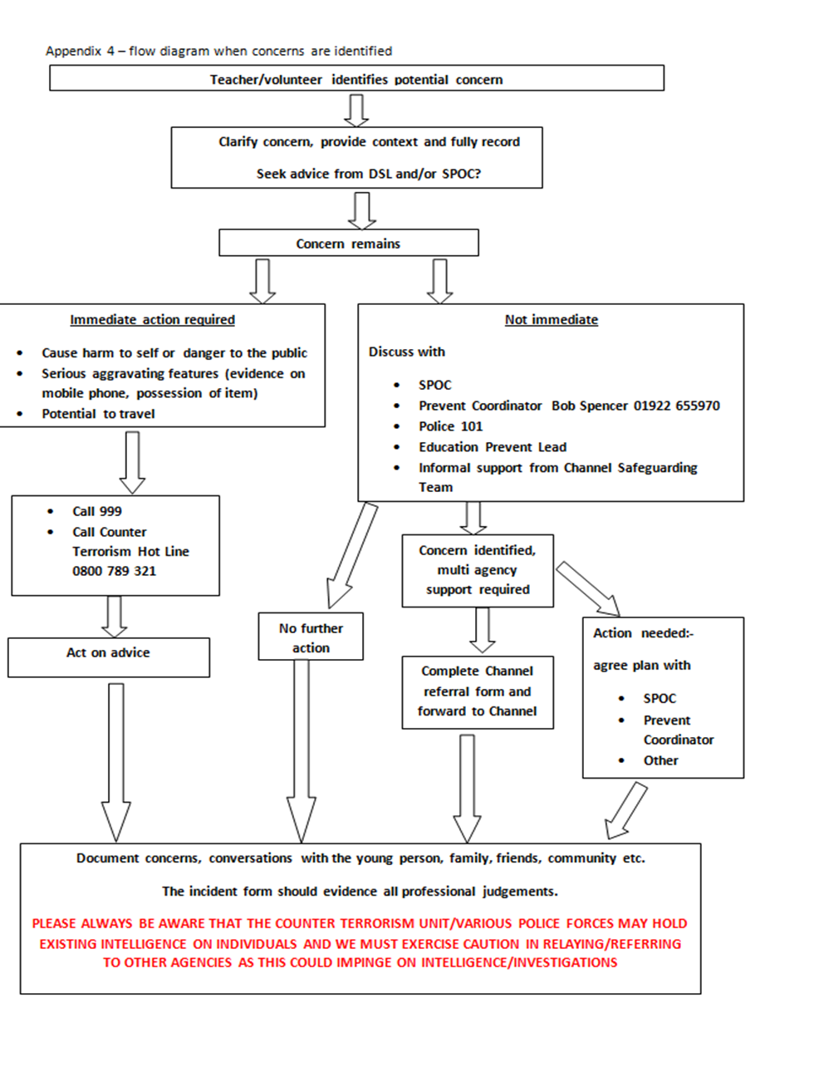
Appendix 2

To be read in conjunction with our current Safeguarding policy.

