KS2 Acceptable use Policy

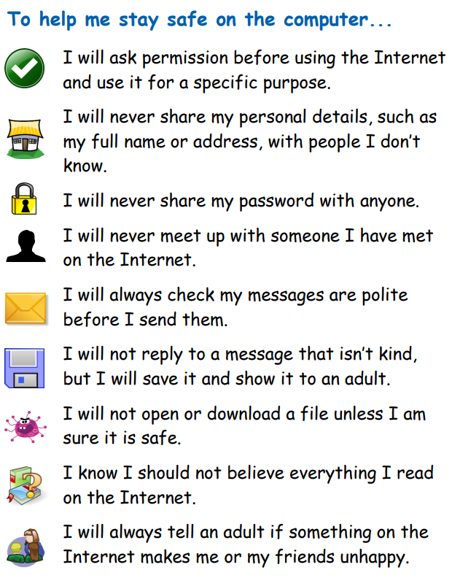
Staying safe whilst using the computer

Signed:_____________________________________________________________________________________________________________________________________________________________________________________________________________________________________________________________________________________________________
___________________________________________________________________________
___________________________________________________________________________
___________________________________________________________________________
___________________________________________________________________________

