Get creative
From Eco Warriors.
Let us get creative, here are some ideas that you could do at home.
- Create a junk model out of plastic.
- Upcycle something old into something new.
- Make a bird feeder for the garden.
https://www.countryliving.com/diy-crafts/how-to/g3060/diy-bird-feeders/?slide=13
https://happyhooligans.ca/32-homemade-bird-feeders/
- Design a poster to educate people about the damage plastic waste causes.
- Help in the garden.
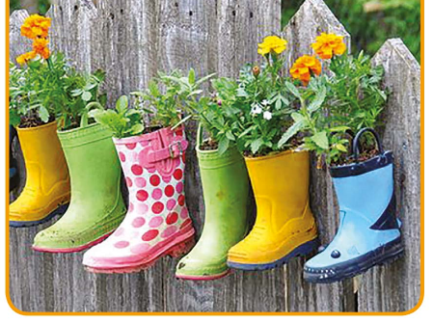
- Use things that you find in your garden to create a picture. For example: leaves, grass cuttings, daisy’s etc.


