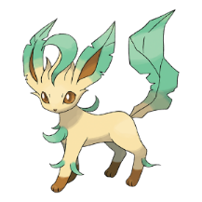
Define the following words in Chapter 2
- Acutely
- Handkerchief
- Slumped
- Reverie
- Circumstances
- Trudge
- Gawping
- Overwhelmed
- Astonishment

Ext: Can you use these words in your own sentences?

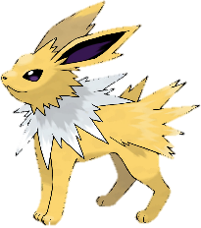
Read Chapter 2 of Oliver Twist. Identify any tricky words and create a list in your book, defining them.

Ext: Record you thoughts on the following questions.

- How is Oliver feeling when he arrives in London?

- Is Dodger being kind when he offers Oliver a place to stay?

- Where do you think Oliver was better off, in the workhouse or with Fagin?

Read Chapter 2 of Oliver Twist. Identify any tricky words and create a list in your book, defining them.

Ext: Record you thoughts on the following questions.

- How is Oliver feeling when he arrives in London?

- Is Dodger being kind when he offers Oliver a place to stay?

- Where do you think Oliver was better off, in the workhouse or with Fagin?


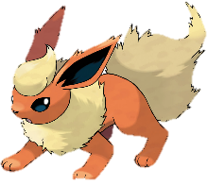
Use the bold words to write your own sentences

He sat down, dazed and exhausted.
The gentleman was horrified at the thought of the injustice.
“Actually it’s business I’m ‘ere about,” said Nancy, briskly.
The stranger listened intently, nodding thoughtfully from time to time.

Ext: Re-read Chapter 2 of Oliver Twist. Identify any other tricky words and create a list in your book, defining them.

Use the bold words to write your own sentences

He sat down, dazed and exhausted.
The gentleman was horrified at the thought of the injustice.
“Actually it’s business I’m ‘ere about,” said Nancy, briskly.
The stranger listened intently, nodding thoughtfully from time to time.

Ext: Re-read Chapter 2 of Oliver Twist. Identify any other tricky words and create a list in your book, defining them.

Use the bold words to write your own sentences

He sat down, dazed and exhausted.
The gentleman was horrified at the thought of the injustice.
“Actually it’s business I’m ‘ere about,” said Nancy, briskly.
The stranger listened intently, nodding thoughtfully from time to time.

Ext: Re-read Chapter 2 of Oliver Twist. Identify any other tricky words and create a list in your book, defining them.

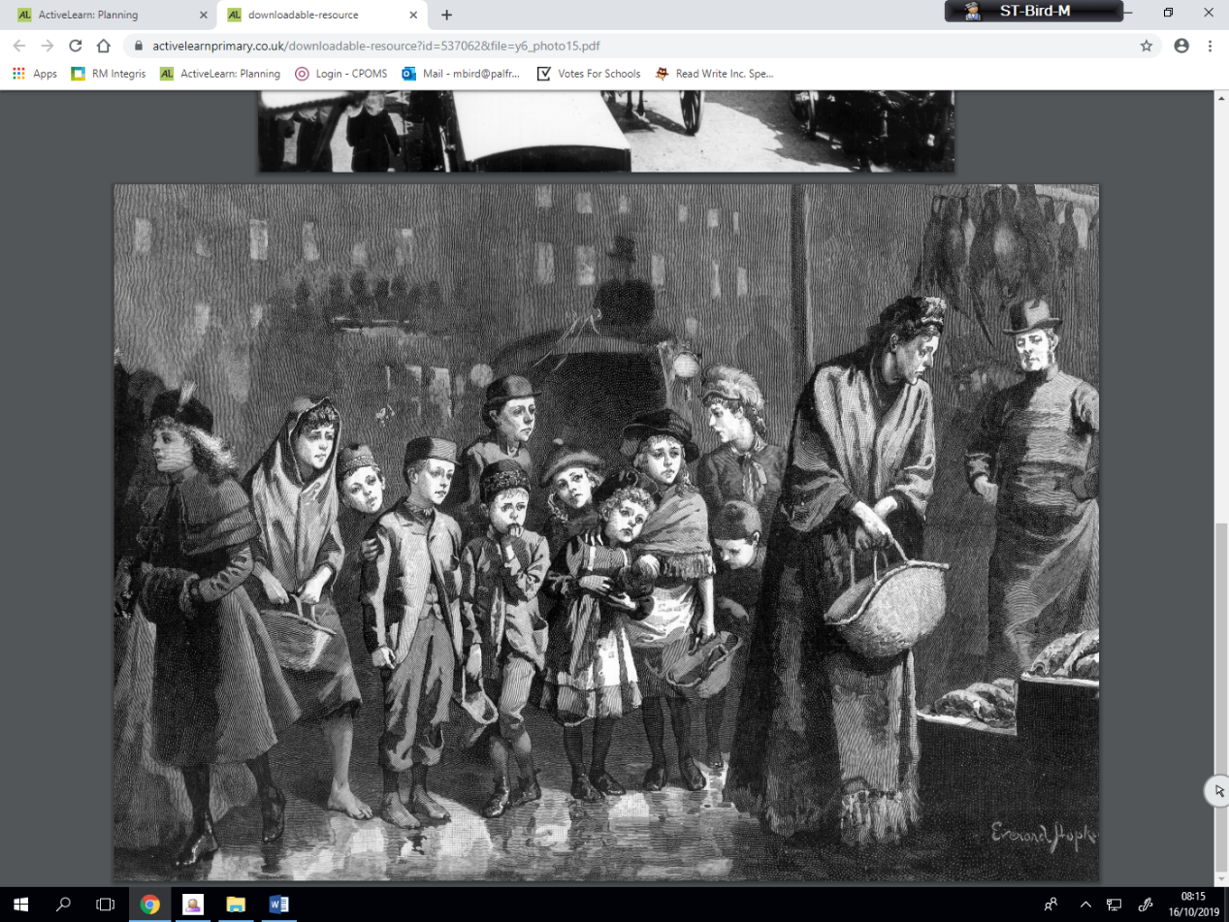
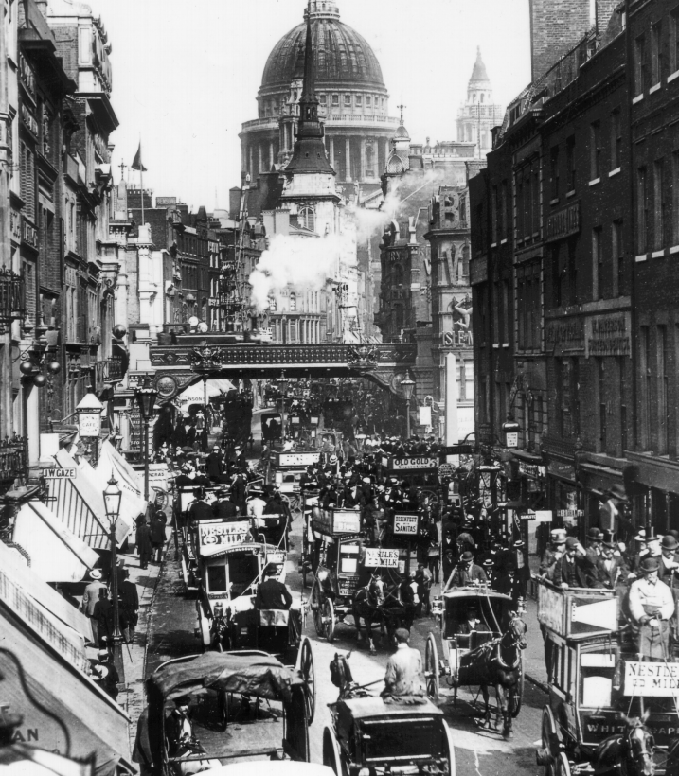
Using Chapter 2, along with the following pictures, write about the following points:

- What do you believe London was like during the Victorian period?
- Imagine and describe how Oliver is feeling when he arrives in London.

Ext: Predict: Will Oliver ever get a real home? Explain your thoughts.

Using Chapter 2, along with the following pictures, write about the following points:

- What do you believe London was like during the Victorian period?

- Imagine and describe how Oliver is feeling when he arrives in London.

Ext: Predict: Will Oliver ever get a real home? Explain your thoughts.

Using Chapter 2, along with the following pictures, write about the following points:

- What do you believe London was like during the Victorian period?

- Imagine and describe how Oliver is feeling when he arrives in London.

Ext: Predict: Will Oliver ever get a real home? Explain your thoughts.

Using Chapter 2, along with the following pictures, write about the following points:

- What do you believe London was like during the Victorian period?

- Imagine and describe how Oliver is feeling when he arrives in London.

Ext: Predict: Will Oliver ever get a real home? Explain your thoughts.

