
Decimal pyramids

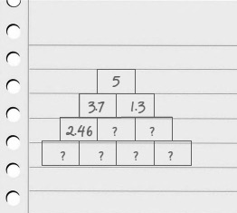
- Draw a pyramid.
Choose a whole number less than 10 to go in the top square.
The numbers in the two squares below must add together to make this number, BUT each of these two numbers must have one decimal place.
- Numbers in the next row must all have two decimal places.
Adjacent numbers must add to give the number above.
- Now it’s getting a little tougher!
The numbers in the bottom row must all have three decimal places.
Once again, adjacent numbers must add to the number above.
- Once you have a solution, copy it into your book.

- What strategies have you found?
Is it easier if you fill in boxes on the outside of the pyramid first or the inside?

- Use what you have learnt to build another decimal pyramid as above.


Challenge
Use the same rules to produce a decimal pyramid with a multiple of 10 at the top.

