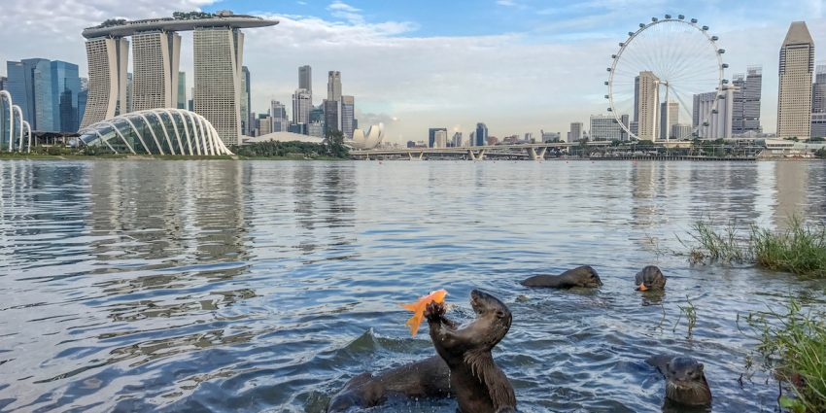
The Return of Singapore’s Wild Otters

Singapore is the third most densely populated country in the world, so it’s surprising that wild otters have decided to recolonise the island. It shows that given a clean environment, awareness and respect, some wildlife can thrive alongside humans, even in busy cities. By Carolyn Beasley
The elderly man stops his bicycle on Jiak Kim Bridge, spanning the Singapore River. ‘The otters are coming,’ he says to a nearby family. ‘Two minutes!’ He’s the self-appointed guardian of this bevy of 10 otters. ‘I’ve just been following them up the river,’ the man continues. ‘Their home is there, in the luxury condo.’ He gestures to a high-rise apartment building, and a small entrance to a ‘holt’ (burrow) in the garden where this lodge is raising pups.
As they watch, fast moving ripples appear on the river surface then a sleek brown head pops up, surveying the scene. Children shriek with delight as more of the nimble creatures appear from downriver.
Finally, all 10 otters are diving, swimming and squabbling before a growing audience. Munching on still-twitching catfish, the pups casually play-wrestle up the riverside stairs. The otters canter nonchalantly past humans with cameras, marking their territory by rubbing and spraying fishy scent on the grassy riverbank.

Making a Comeback
Singapore’s otters are back in a big way, with at least 60 now calling the island home, inhabiting rivers, canals, mangroves and beaches. Native to many parts of Asia, the smooth-coated otter is listed as ‘critically endangered’ in the Red List of threatened animals of Singapore, and worldwide the species is considered ‘vulnerable.’
Smooth-coated otters were completely absent from Singapore in the 1970s and 80s visiting just occasionally after that, but mostly not venturing beyond the coastal and mangrove zones. During that time, Singapore was undergoing rapid urbanisation. The inland rivers and waterways were polluted and intensive construction and land reclamation works disturbed coastal areas.
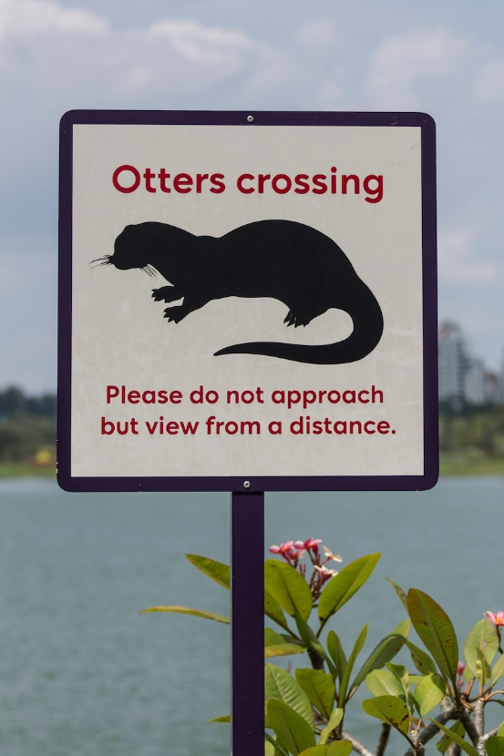
With much of this construction phase now completed, Singapore has turned its attention to enhancing biodiversity. In 2009 the National Parks Board (NParks) launched the National Biodiversity Strategy and Action Plan, and in 2013 introduced a campaign called ‘City in a Garden.’
This seeks to create the best living environment for communities through recognising the vital link to nature. As part of this campaign, in 2013 the Public Utilities Board, responsible for water infrastructure, removed a concrete canal that ran through one of Singapore’s largest urban parks, Bishan-Ang Mo Kio Park. A natural, rehabilitated riverbed replaced the canal, bringing the Kallang River back into the park and providing the public with new recreational activities.
A year later, the otters were spotted in the river. Much to the delight of local residents, this clean stream, full of fish, provided the first site in Singapore for otters to raise pups.
The otters have gained huge popularity throughout Singapore. ‘Ottie the otter’ has been chosen by the People’s Association as a giant mascot for their Project Blue Wave, a conservation movement backed by the government. The otter represents the conservation message perfectly, since the return of the otter is due to the environmental clean-up in Singapore. As some otters have been injured or killed through discarded waste such as fish hooks or Styrofoam, the otter also reminds the public of the vulnerability of the marine environment.

Second Chance
Mr Jeff Teo is a photographer and one volunteer behind Otterwatch. ‘Singapore grew up with generations of people thinking the only wild animals were stray cats and dogs,’ he laughs: ‘This journey is a test of Singaporeans. We are good at telling other countries what to do, such as protect your orangutans, don’t eat shark fin. But now, we have animals in our backyard, we must treat them well. Otherwise who are we to tell the world what to do?
‘Once we had these animals, and we lost them. So the otters’ return is our second chance.’
Jeff says: ‘In Singapore, we have regained our otters through cleaner waterways. Also, coastal development in neighbouring countries such as Indonesia and Malaysia may also be disturbing otters, causing them to seek new homes in Singapore. By documenting our journey of how people can live with otters, we hope to share this experience with our neighbours one day.’
An Otter Working Group of government officials and volunteers has installed otter-watching signage at otter hot spots. Although some otters are exhibiting friendliness to humans, Jeff cautions the public to give the otters space. ‘If, for whatever stupid reason, humans provoke otters, they will still bite. When that happens, otters won’t win. The government may be pressured to cull them,’ Jeff explains. ‘We need to be good hosts to our otters or they will leave. We will not get a third chance at this.’

