
Hi Kids,
We would love for you to fill in this health tracker (NEXT PAGE) with a picture and a sentence for each section. Please think about how you are keeping yourself physically and mentally healthy in some of the following ways:
- exercising safely, 
- playing board games
- cycling,
- dancing
- listening to music,
- enjoying playing in the garden,
- painting,
- reading books,
- eating healthy
If you like, you can fill in one tracker for each week at home to show us how you are keeping yourself healthy. Please email the school with some of your ideas. We would love to see them.

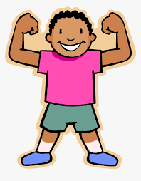
Health Tracker
Track the ways you have been keeping healthy this week. You can write or draw a picture.
Monday  | Monday | Monday | Monday | Monday
Tuesday | Tuesday | Tuesday | Tuesday | Tuesday
Wednesday | Wednesday | Wednesday | Wednesday | Wednesday
Thursday | Thursday | Thursday | Thursday | Thursday
Friday | Friday | Friday | Friday | Friday

