Reading 16.11.20
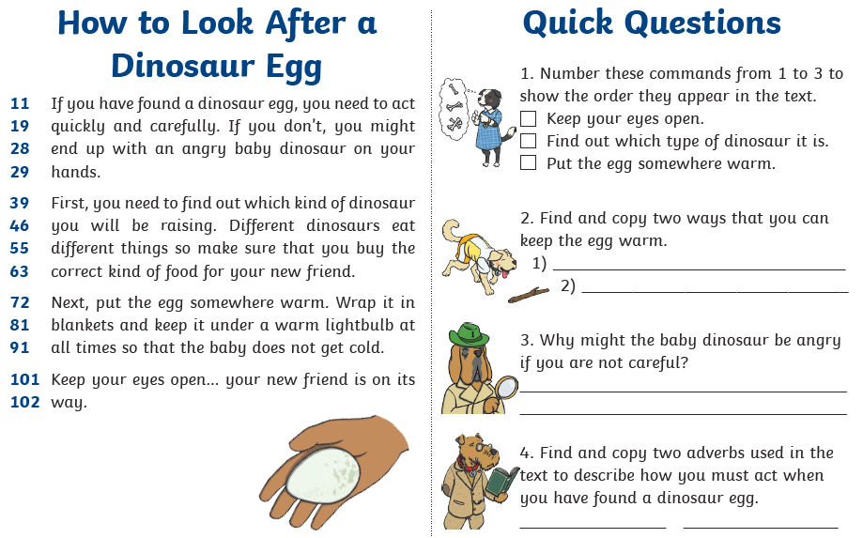
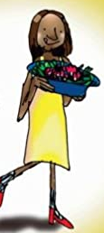
17.11.20
Grow your own radishes

Did you know that you can grow your very own crop of radishes in just three weeks?

You must sow the seeds in spring. If you want lots of fresh radishes, sow a batch of seeds every three weeks.

Let me show you the best way to grow your own radishes!

You will need:
- A packet of radish seeds
- A shallow plant pot or a window box
- A bag of potting compost
- Some sand
- A black bin bag

What to do:
- Fill the plant pot or window box with potting compost.
- Lay some sand on top of the compost.
- Sow the seeds in three rows. The seeds must be just below the level of the compost.
- Put a sheet of black bin bag on the top. This will help the seeds to grow, as well as stopping sparrows from pecking them up.
- Ask a grown-up to help you to put the pot or window box in a sunny spot on a window sill, away from the wind. (If the window sill is very narrow, the pot may fall off).
- The radish plants will slowly begin to grow. (The small plants are called seedlings). Then you can lift off the bin bag.
- Keep the compost damp, and pull out any weeds that grow in the pot or window box.
- Keep checking the radish plants. When they are 10cm high, radishes will have grown below the compost.
- (This is the best bit!) Pull up the radishes when they are 2-3cm long. (You can check their length if you push back a bit of compost).
- Mix up a fantastic fresh radish salad! Wash the radishes well, and put them in a big bowl. Then you can add chopped carrots, leeks, cress, shallots or nuts.

18.11.20
Answer the questions about ‘Grow your own radishes’.

How long does it take to grow radishes?
Why are there five bullet points?
What must you do after putting compost in the pot?
Why must you put a bin bag on the top of the pot?
When do you take the bin bag off?
How do you know when the radishes have grown below the soil?
How could you eat the radishes?

___________________________________________________
___________________________________________________
___________________________________________________
___________________________________________________
___________________________________________________
___________________________________________________
___________________________________________________
___________________________________________________
___________________________________________________
___________________________________________________
___________________________________________________
___________________________________________________
___________________________________________________
___________________________________________________
___________________________________________________
___________________________________________________
___________________________________________________
___________________________________________________
___________________________________________________
___________________________________________________
___________________________________________________
___________________________________________________
___________________________________________________
___________________________________________________
___________________________________________________
___________________________________________________
___________________________________________________
___________________________________________________
___________________________________________________
___________________________________________________
___________________________________________________
___________________________________________________
___________________________________________________
___________________________________________________
___________________________________________________
___________________________________________________
___________________________________________________

